2017

Constantin Toader

B00243868

2/5/2017

Mandelbrot set

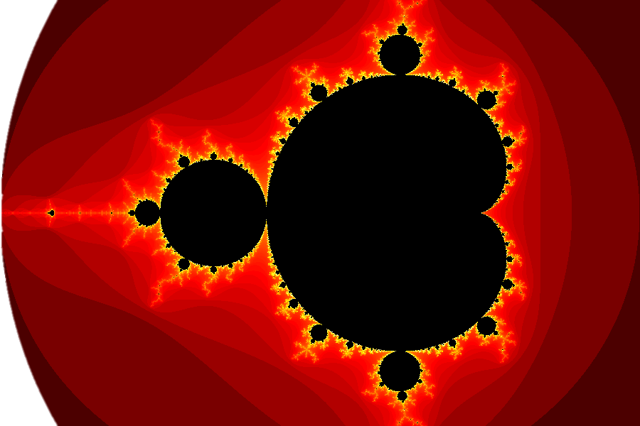

## The Mandelbrot Set

The term Mandelbrot set is used to refer both to a general class of fractal sets and to a particular instance of such a set. In general, a Mandelbrot set marks the set of points in the complex plane such that the corresponding Julia set is connected and not computable.

The Mandelbrot set is the set obtained from the quadratic recurrence equation

$$z_{n+1}= z_{n}^{2}+ C$$

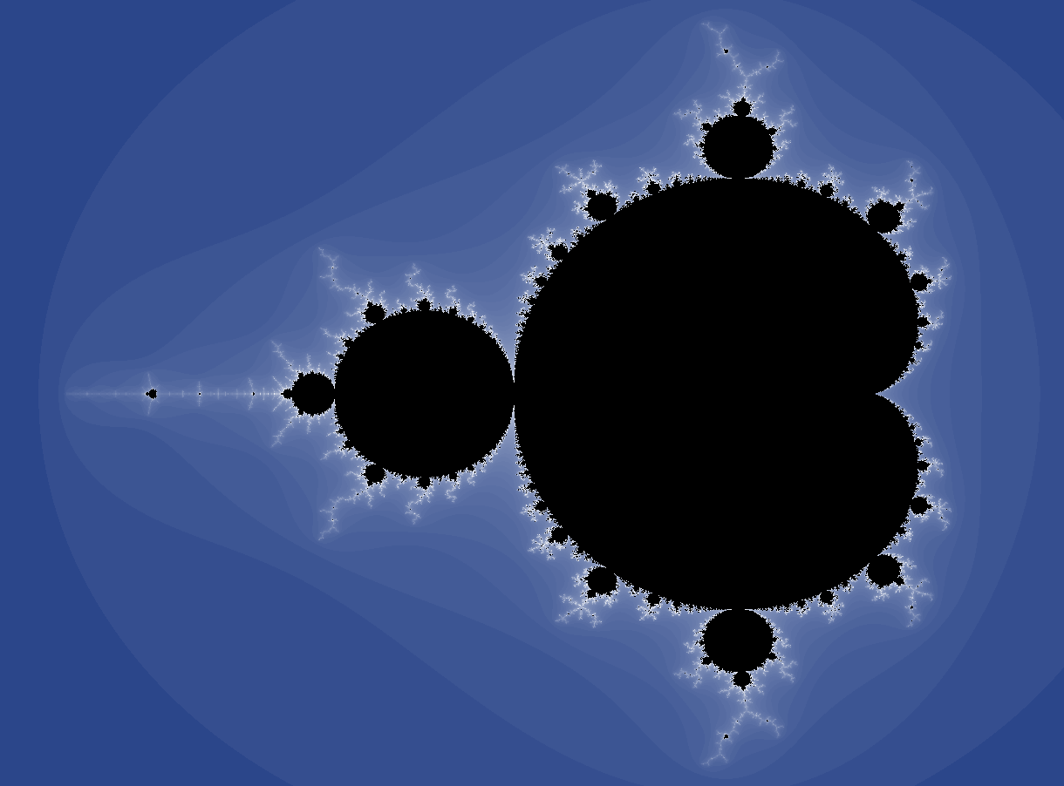With $z_{0}= C$, where points $C$ in the complex plane for which the orbit of $z_{n}$ does not tend to infinity are in the set. Setting $z_{0}$ equal to any point **in the set** that is not a periodic point gives the same result (Weisstein, n.d.).

The Mandelbrot set is the dark glob in the centre of the picture. The colour of the pixels outside indicate how many iterations it took for each of those pixels until the condition for being outside the Mandelbrot set was satisfied. Figure 1. Mandelbrot Set (Mandelbrot Set, n.d.)

## The Algorithm

In pseudocode, the algorithm looks as the following:

For each pixel (Px, Py) on the screen, do:

{

x0 = scaled x coordinate of pixel (between (-2.5, 1))

y0 = scaled y coordinate of pixel (between (-1, 1))

x = 0.0

y = 0.0

iteration = 0

max_iteration = 1000

while (x*x + y*y < 2*2 AND iteration < max_iteration) {

xtemp = x*x - y*y + x0

y = 2*x*y + y0

x = xtemp

iteration = iteration + 1

}

color = palette[iteration]

plot(Px, Py, color)

}

Figure 2. Pseudocode (En.wikipedia.org, 2017)

## The Problem

Given a sample code that can generate a section of the Mandelbrot set using a Central Processing Unit, there is a requirement to optimise and port the execution of the application to a General Purpose Graphic Processing Unit using Nvidia’s CUDA API.

## The Sample Code

Compiling the code generates an executable, which, when executed, saves a section of an instance of the Mandelbrot set to a ppm image file with a size of 4096x4096 pixels.

The main program is composed of three functions with the following execution times:

* *alloc_2d* ***–*** **13 ms:** reserves memory for the image to be generated;
* *calc_mandel* **– 3420 ms:** fills the pixels with the right colours reflecting the Mandelbrot set;
* *screen_dump* ***–* 236 ms:** saves the generated data to an image file, for a better visualisation;

Figure 3. Execution time for each function in CPU-based solution

During the execution, *calc_mandel* calls another function *map_colour.* This is the code of the function:

void map_colour(rgb_t * const px)

{

***const uchar num_shades = 16;***

***const rgb_t mapping[num_shades] =***

***{{66,30,15}, {25,7,26}, {9,1,47}, {4,4,73}, {0,7,100},***

***{12,44,138}, {24,82,177}, {57,125,209}, {134,181,229},{211,236,248},***

***{241,233,191},{248,201,95}, {255,170,0}, {204,128,0}, {153,87,0},***

***{106,52,3}};***

if (px->r == max_iter || px->r == 0) {

px->r = 0; px->g = 0; px->b = 0;

} else {

***const uchar uc = px->r % num_shades;***

*px = mapping[uc];

}

}

With italic bold is highlighted the code that slows the execution time.

This code is executed in the *calc_mandel­* function for height *x* width iterations, and with each iteration we create the shades in the body of the map_colour, and with each iteraration a pixel is evaluated and given a colour.

During the execution of the *calc_mandel* we already traverse all the pixels, so the shade attribution for each pixel could be done inside the for loops belonging to the *calc_mandel*.

## Sample code optimisation

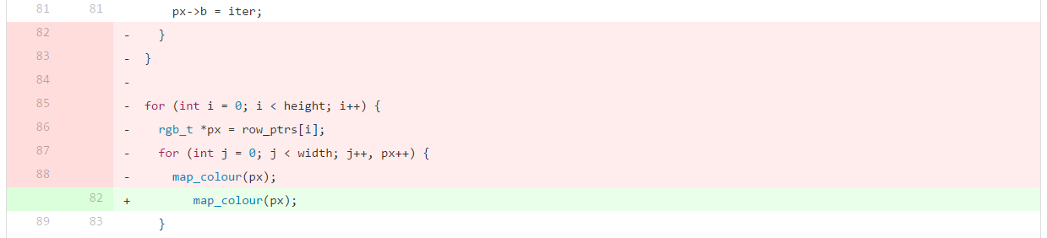Before optimising the code on the GPU, improvements can be done to the code running on the CPU. To highlight the performance gain, the code was executed 5 times and the average execution time was measured with each improvement. The measurement was done with a high_resolution_clock.

Figure 4. Default Code optimisation - Attempt 1

The first attempt was to move the map_colour in the for loops from the calc_mandel function as shown in Figure 3. Interestingly after doing this, the performance dropped and the execution time grew from 3630 milliseconds to 3789 milliseconds. Seeing that this was not a good result the code was reverted.

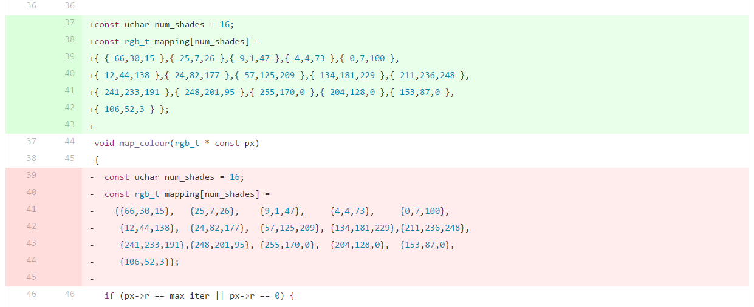

Figure 5. Default Code optimisation - Attempt 2

The second attempt was to move the declaration of the shades outside of the map_colour function as seen in Figure 4. This means that the shades would only be declared only one time, even though they would sit in the global scope. The results show a performance gain, with the execution time dropping from 3630 milliseconds to 3325 milliseconds.

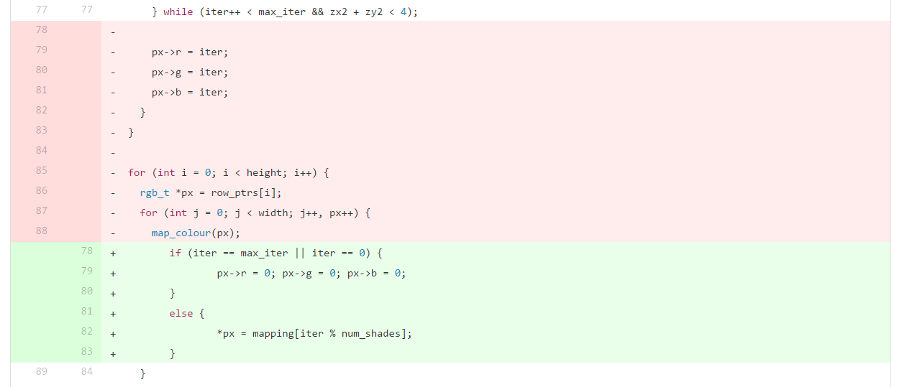

Figure 6. Default Code optimisation - Attempt 3

The last step was to try again to move the colouring step in the calc_mandel for loop, but this time by eliminating the map_colour function, and to evaluate the pixel using the value of iter, as shown in Figure 5. Also, to calculate the right index of the shade, the local declaration of the uc has been removed. The results highlight another performance gain, with the execution time dropping from the previous result of 3325 milliseconds to 2959 milliseconds.

Overall with the current changes, the code runs faster, on average, with 671.4 milliseconds, a 18% performance gain.

Figure 7. Default code optimisation graph (lower is better)

## Cuda version

With CUDA, *host* CPU code can launch GPU *kernels* by calling *device* functions that execute on the GPU.

The necessary steps to convert the serial code into code running with the CUDA API are the following:

* create handles for the image data for both device and host
* allocate device memory for the device image data
* prepare kernel
  + - find grid size and block size
    - calculate index
    - run Mandelbrot algorithm
* retrieve image from device
* output image to file
* clean-up

To abstract away the functionality related to the creation of a Mandelbrot set, the code related to it has been encapsulated in a separated class. The class is defined by the width, height and the starting complex number which is tested if it is inside a such set. Also, two pointers are being declared to easy identify the image data on the host and on the device.

The constructor is responsible for instant allocation of memory on the device using an init() function, but also an array of Pixels is reserved on the host. The destructor is responsible for cleaning up the memory. Memory from both host and device is freed when the destructor is called.

Other function is fetch() which syncs the GPU processing units and copies the image data from device to host. The last useful function (ignoring the getters and setters) is the saveAs() function, which takes a string as a parameter to use as a name when writing the image to disk. This function does not check if there is any data on the host data, so it should be used only after the data has been fetched from the device.

The Util.h header file holds directives and definitions for some constants and structs. A check() function improves logging the cudaError_t. Another useful utility is the measure template which records the execution time for any method passed to it.

## Running the first CUDA version

There are two important aspects to be considered before starting to use the CUDA API: index calculation and kernel parameters identification.

int row = blockIdx.y * blockDim.y + threadIdx.y;

int column = blockIdx.x * blockDim.x + threadIdx.x;

int index = row * width + column;

The other aspect involved calculating the grid size and block size. To try to find the right values, we need to consider the warp size of 32 to avoid padding, so for the block sizes, a multiple of 32 seems to be a good candidate (talonmies, 2012) Once a block size has been identified, the number of blocks, the grid size will be computed by dividing the image data to the number of threads activated for each block.

So, for example, to obtain a theoretical occupancy of 1, for a 4096x4096 image, the following gridSize-blockSize pairs will be used in a 2D kernel: (notice that multiplying all these values should always be equal to the amount of pixels that need to be processed – 16,777,216)

|  |  |  |  |  |  |  |  |  |
| --- | --- | --- | --- | --- | --- | --- | --- | --- |
| Blocks: | 128x128 | 64x64 | 32x32 | 16x16 | 8x8 | 4x4 | 2x2 | 1x1 |
| Threads: | 32x32 | 64x64 | 128x128 | 256x256 | 512x512 | 1024x1024 | 2048x2048 | 4096x4096 |

Arbitrarily, the most balanced values were used for the first execution of the code:

. . . . . . . . .

dim3 blockSize(64, 64);

dim3 gridSize(64, 64);

calc_mandel << <blocks, threads>> >();

. . . . . . . . .

Another aspect was to make sure that the shades used at each iteration are immediately available to be used on each block. For this, the array of shades has been globally declared as __constant__.

## Averaging and measuring – Methodology

To try to find the best execution times for a piece of code, micro-benchmarking has been performed using the following procedure:

Given a target code which requires its execution time to be measured, we surround it between a start and end timer, record the difference and repeat this process for an arbitrary chosen number of cycles and average the differences. This process is again repeated for different kernel configurations and each average time is saved along with the configuration it has been used. The lowest average should highlight the best kernel configuration. The process is again repeated for different image resolutions. All timings are recorded in different files (one file with timings for each resolution) and through observation, the fastest times will be highlighted.

For each cycle

Assign current time instance to start

Run block of code

Assign current time to end

Add difference to total cycle time

End for

Record time/cycles as average execution time.

## Cuda Occupancy API

To ease the optimisation, Harris (2014) suggests to use the Occupancy API if a CUDA 6.5 or higher is available. The API makes it possible to compute an efficient execution configuration for a kernel.

# References

En.wikipedia.org. (2017). *Mandelbrot set*. [online] Available at: <https://en.wikipedia.org/wiki/Mandelbrot_set#Escape_time_algorithm> [Accessed 5 Feb. 2017].

Harris, M. (2014). *CUDA Pro Tip: Occupancy API Simplifies Launch Configuration*. [online] Parallel Forall. Available at: https://devblogs.nvidia.com/parallelforall/cuda-pro-tip-occupancy-api-simplifies-launch-configuration/ [Accessed 13 Feb. 2017].

Mandelbrot Set. (n.d.). [image] Available at: <http://www.math.utah.edu/~alfeld/math/mandelbrot/large.gif> [Accessed 5 Feb. 2017].

Weisstein, E. (n.d.). *Mandelbrot Set -- from Wolfram MathWorld*. [online] Mathworld.wolfram.com. Available at: <http://mathworld.wolfram.com/MandelbrotSet.html> [Accessed 5 Feb. 2017].

talonmies,. (2012). *How do I choose grid and block dimensions for CUDA kernels?*. *Stackoverflow.com*. Retrieved 10 February 2017, from <http://stackoverflow.com/questions/9985912/how-do-i-choose-grid-and-block-dimensions-for-cuda-kernels>

# Extra reading materials

<http://www.stuffedcow.net/research/cudabmk>

<http://docs.nvidia.com/cuda/cuda-driver-api/group__CUDA__OCCUPANCY.html#group__CUDA__OCCUPANCY_1g04c0bb65630f82d9b99a5ca0203ee5aa>

<https://devblogs.nvidia.com/parallelforall/cuda-pro-tip-occupancy-api-simplifies-launch-configuration/>